Considering the operator: {'V15Isotropic': {'J': 800.0, 'J1': 225.0, 'J2': 350.0}}

Using the sampler: {'MetropolisHastings': {'nflips': 1, 'nmoves': 150000, 'nsweeps': 10000, 'sweepfactor': 1.0, 'thermfactor': 0.1}}

Using the optimizer: {'SGD': {'learning_rate': 0.0001, 'schedule_multiplier': 'fixed', 'SR': {'lambd0': 100.0, 'b': 0.8-0.9, 'lambdMin': 0.0001}, 'L2': {'L2_factor': 0.0001}}}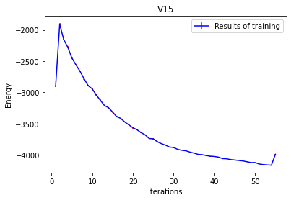

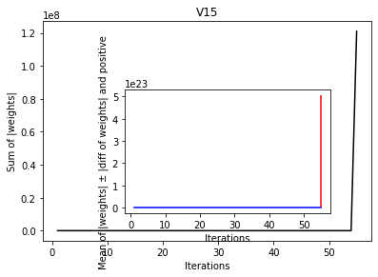

Considering the operator: {'V15Isotropic': {'J': 800.0, 'J1': 225.0, 'J2': 350.0}}

Using the sampler: {'MetropolisHastings': {'nflips': 1, 'nmoves': 150000, 'nsweeps': 10000, 'sweepfactor': 1.0, 'thermfactor': 0.1}}

Using the optimizer: {'SGD': {'learning_rate': **1e-05**, 'schedule_multiplier': 'fixed', 'SR': {**'lambd0': 1000.0**, 'b': 0.8, **'lambdMin': 10.0**}, 'L2': {'L2_factor': 0.0001}}}

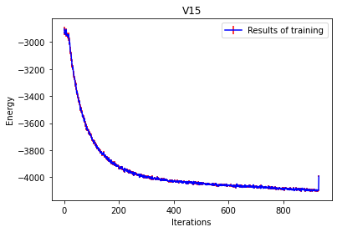

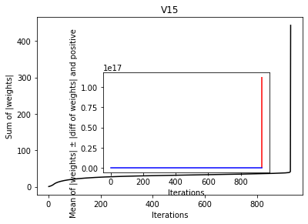

Considering the operator: {'V15Isotropic': {'J': 800.0, 'J1': 225.0, 'J2': 350.0}}

Using the sampler: {'MetropolisHastings': {'nflips': 1, 'nmoves': 150000, 'nsweeps': 10000, 'sweepfactor': 1.0, 'thermfactor': 0.1}}

Using the optimizer: {'SGD': {'learning_rate': 1e-05, 'schedule_multiplier': 'fixed', 'SR': {'lambd0': **100.0**, 'b': **0.99**, 'lambdMin': 10}, 'L2': {'L2_factor': 0.0001}}}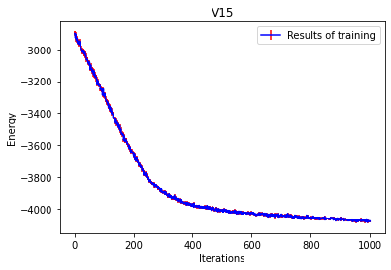

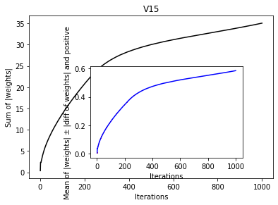

Considering the operator: {'V15Isotropic': {'J': 800.0, 'J1': 225.0, 'J2': 350.0}}

Using the sampler: {'MetropolisHastings': {'nflips': 1, 'nmoves': 150000, 'nsweeps': 10000, 'sweepfactor': 1.0, 'thermfactor': 0.1}}

Using the optimizer: {'SGD': {**'learning_rate': 0.0001**, 'schedule_multiplier': 'fixed', 'SR': {'lambd0': 100.0, 'b': 0.99, 'lambdMin': 10.0}, 'L2': {'L2_factor': 0.0001}}}

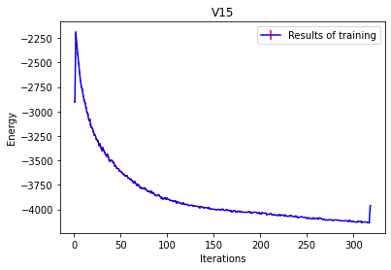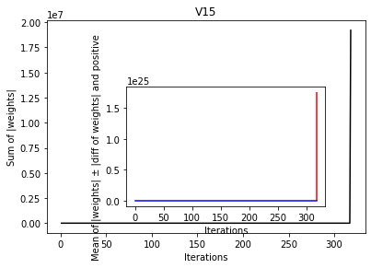

Considering the operator: {'V15Isotropic': {'J': 800.0, 'J1': 225.0, 'J2': 350.0}}

Using the sampler: {'MetropolisHastings': {'nflips': 1, 'nmoves': 150000, 'nsweeps': 10000, 'sweepfactor': 1.0, 'thermfactor': 0.1}}

Using the optimizer: {'SGD': {**'learning_rate': 5e-05**, 'schedule_multiplier': 'fixed', 'SR': {'lambd0': 100.0, 'b': 0.99, 'lambdMin': 10.0}, 'L2': {'L2_factor': 0.0001}}}

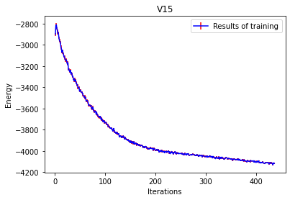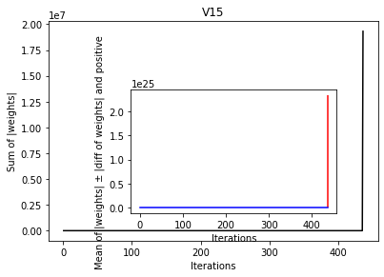

Considering the operator: {'V15Isotropic': {'J': 800.0, 'J1': 225.0, 'J2': 350.0}}

Using the sampler: {'MetropolisHastings': {'nflips': 1, 'nmoves': 150000, 'nsweeps': 10000, 'sweepfactor': 1.0, 'thermfactor': 0.1}}

Using the optimizer: {**'Adam'**: {'learning_rate': 0.005, 'schedule_multiplier': 'fixed', 'first_momentum_factor': 0.9, 'second_momentum_factor': 0.999, 'SR': {'lambd0': 500.0, 'b': 0.8, 'lambdMin': 100.0}, 'L2': {'L2_factor': 0.0001}}}

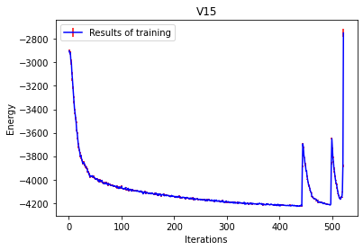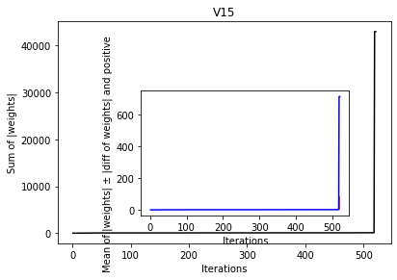

Considering the operator: {'V15Isotropic': {'J': 800.0, 'J1': 225.0, 'J2': 350.0}}

Using the sampler: {'MetropolisHastings': {'nflips': 1, 'nmoves': 150000, 'nsweeps': 10000, 'sweepfactor': 1.0, 'thermfactor': 0.1}}

Using the optimizer: {'Adam': {'learning_rate': **0.0001**, 'schedule_multiplier': 'fixed', 'first_momentum_factor': 0.9, 'second_momentum_factor': 0.999, 'SR': {'lambd0': **1000.0**, 'b': 0.8, 'lambdMin': **10.0**}, 'L2': {'L2_factor': 0.0001}}}

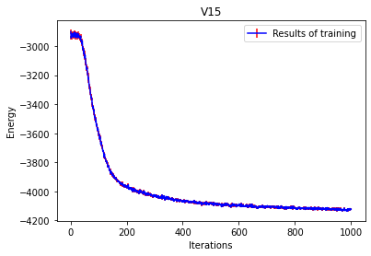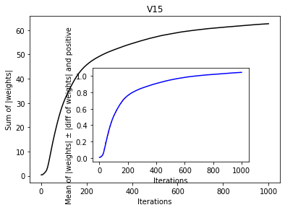

Considering the operator: {'V15Isotropic': {'J': 800.0, 'J1': 225.0, 'J2': 350.0}}

Using the sampler: {'MetropolisHastings': {'nflips': 1, 'nmoves': 150000, 'nsweeps': 10000, 'sweepfactor': 1.0, 'thermfactor': 0.1}}

Using the optimizer: {'Adam': {'learning_rate': **0.0005**, 'schedule_multiplier': 'fixed', 'first_momentum_factor': 0.9, 'second_momentum_factor': 0.999, 'SR': {'lambd0': **100.0**, 'b': **0.99**, 'lambdMin': 10.0}, 'L2': {'L2_factor': 0.0001}}}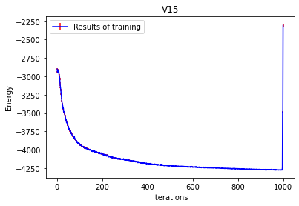

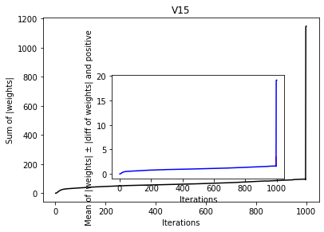

Considering the operator: {'V15Isotropic': {'J': 800.0, 'J1': 225.0, 'J2': 350.0}}

Using the sampler: {'MetropolisHastings': {'nflips': 1, 'nmoves': 150000, 'nsweeps': 10000, 'sweepfactor': 1.0, 'thermfactor': 0.1}}

Using the optimizer: {'Adam': {'learning_rate': 0.0005, 'schedule_multiplier': {**'type': 'decayed', 'decay_factor': 0.999**}, 'first_momentum_factor': 0.9, 'second_momentum_factor': 0.999, 'SR': {'lambd0': 100.0, 'b': 0.99, 'lambdMin': 10.0}, 'L2': {'L2_factor': 0.0001}}}

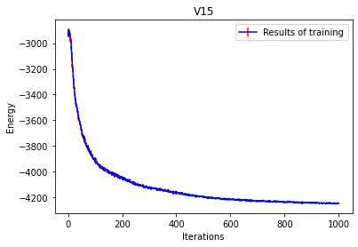

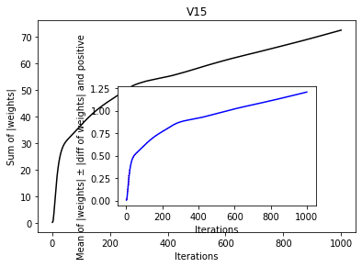

Considering the operator: {'V15Isotropic': {'J': 800.0, 'J1': 225.0, 'J2': 350.0}}

Using the sampler: {'MetropolisHastings': {'nflips': 1, 'nmoves': 150000, 'nsweeps': 10000, 'sweepfactor': 1.0, 'thermfactor': 0.1}}

Using the optimizer: {'Adam': {'learning_rate': 0.0005, 'schedule_multiplier': {'type': 'decayed', 'decay_factor': 0.999}, 'first_momentum_factor': 0.9, 'second_momentum_factor': 0.999, 'SR': {'lambd0': 100.0, 'b': 0.99, 'lambdMin': 10.0}, 'L2': {'L2_factor': 0.0001}}}

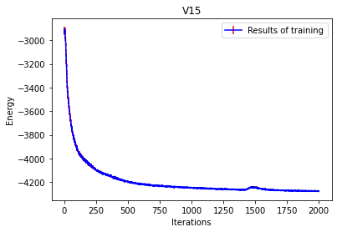

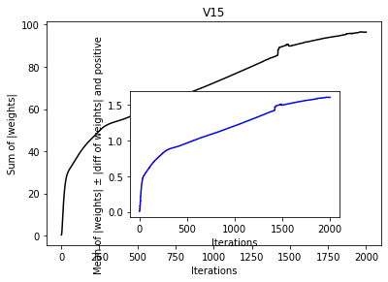

Considering the operator: {'V15Isotropic': {'J': 800.0, 'J1': 225.0, 'J2': 350.0}}

Using the sampler: {'MetropolisHastings': {'nflips': 1, 'nmoves': 150000, 'nsweeps': 10000, 'sweepfactor': 1.0, 'thermfactor': 0.1}}

Using the optimizer: {'Adam': {**'learning_rate': 0.01**, 'schedule_multiplier': **'fixed**', 'first_momentum_factor': 0.9, 'second_momentum_factor': 0.999, **'SR': False**, 'L2': {'L2_factor': 0.0001}}}

**Failed**

Considering the operator: {'V15Isotropic': {'J': 800.0, 'J1': 225.0, 'J2': 350.0}}

Using the sampler: {'MetropolisHastings': {'nflips': 1, 'nmoves': 150000, 'nsweeps': 10000, 'sweepfactor': 1.0, 'thermfactor': 0.1}}

Using the optimizer: {'Adam': {**'learning_rate': 0.001**, 'schedule_multiplier': 'fixed', 'first_momentum_factor': 0.9, 'second_momentum_factor': 0.999, 'SR': False, 'L2': {'L2_factor': 0.0001}}}

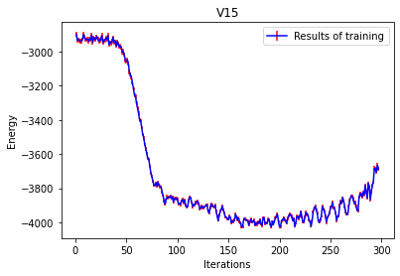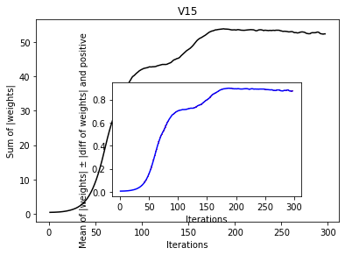

Considering the operator: {'V15Isotropic': {'J': 800.0, 'J1': 225.0, 'J2': 350.0}}

Using the sampler: {'MetropolisHastings': {'nflips': 1, 'nmoves': 150000, 'nsweeps': 10000, 'sweepfactor': 1.0, 'thermfactor': 0.1}}

Using the optimizer: {**'Momentum'**: {'learning_rate': 1e-05, 'schedule_multiplier': {'type': 'decayed', 'decay_factor': 0.999}, 'momentum_factor': 0.9, 'SR': {'lambd0': 100.0, 'b': 0.99, 'lambdMin': 10.0}, 'L2': {'L2_factor': 0.0001}}}

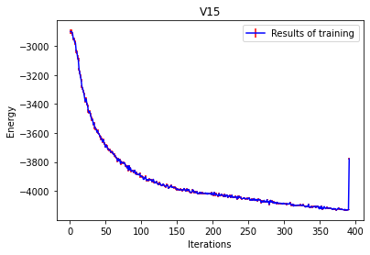

Considering the operator: {'V15Isotropic': {'J': 800.0, 'J1': 225.0, 'J2': 350.0}}

Using the sampler: {'MetropolisHastings': {'nflips': 1, 'nmoves': 150000, 'nsweeps': 10000, 'sweepfactor': 1.0, 'thermfactor': 0.1}}

Using the optimizer: {'Momentum': {'learning_rate': 1e-05, 'schedule_multiplier': {'type': 'decayed', 'decay_factor': 0.999}, 'momentum_factor': 0.9, 'SR': {**'lambd0': 500.0, 'b': 0.99, 'lambdMin': 50.0**}, 'L2': {'L2_factor': 0.0001}}}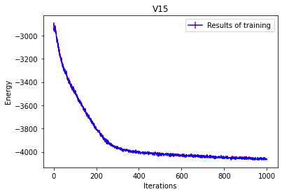

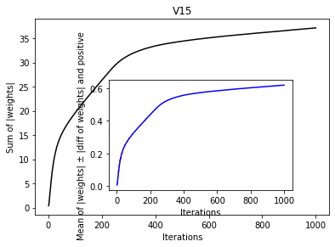

Considering the operator: {'V15Isotropic': {'J': 800.0, 'J1': 225.0, 'J2': 350.0}}

Using the sampler: {'MetropolisHastings': {'nflips': 1, 'nmoves': 150000, 'nsweeps': 10000, 'sweepfactor': 1.0, 'thermfactor': 0.1}}

Using the optimizer: {'Momentum': {'learning_rate': **0.0001**, 'schedule_multiplier': {'type': 'decayed', 'decay_factor': 0.999}, 'momentum_factor': 0.9, **'SR': False**, 'L2': {'L2_factor': 0.0001}}}

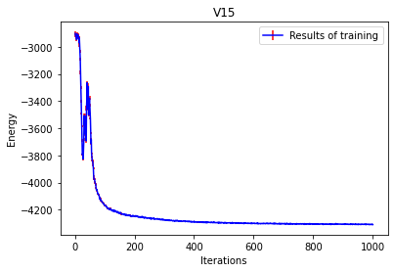

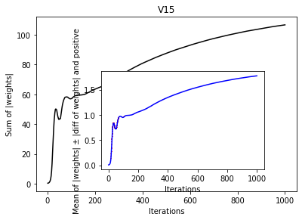

Considering the operator: {'V15Isotropic': {'J': 800.0, 'J1': 225.0, 'J2': 350.0}}

Using the sampler: {'MetropolisHastings': {'nflips': 1, 'nmoves': 150000, 'nsweeps': 10000, 'sweepfactor': 1.0, 'thermfactor': 0.1}}

Using the optimizer: {'Momentum': {**'learning_rate': 0.001**, 'schedule_multiplier': **'fixed'**, 'momentum_factor': 0.9, 'SR': False, 'L2': {'L2_factor': 0.0001}}}

**Failed**

Considering the operator: {'V15Isotropic': {'J': 800.0, 'J1': 225.0, 'J2': 350.0}}

Using the sampler: {'MetropolisHastings': {'nflips': 1, 'nmoves': 150000, 'nsweeps': 10000, 'sweepfactor': 1.0, 'thermfactor': 0.1}}

Using the optimizer: {'Momentum': {**'learning_rate': 0.0003**, 'schedule_multiplier': 'fixed', 'momentum_factor': 0.9, 'SR': False, 'L2': {'L2_factor': 0.0001}}}

**Failed**

Considering the operator: {'V15Isotropic': {'J': 800.0, 'J1': 225.0, 'J2': 350.0}}

Using the sampler: {'MetropolisHastings': {'nflips': 1, 'nmoves': 150000, 'nsweeps': 10000, 'sweepfactor': 1.0, 'thermfactor': 0.1}}

Using the optimizer: {'Momentum': {**'learning_rate': 0.0001**, 'schedule_multiplier': 'fixed', 'momentum_factor': 0.9, 'SR': False, 'L2': {'L2_factor': 0.0001}}}